

SCHOOL OF INFORMATICS & IT

Diploma in Information Technology

Part 1: Implementation of DevOps Practices

Student Name (Matric Number) : Nur Syakirah (2405298G)

Tutorial Group : PC02
Jenny LING (TP)
Tutor : Allen Tan

Submission Date : 24/11/2025

Declaration of Originality

I am the originator of this work and I have appropriately acknowledged all other original sources used as my references for this work.

I understand that Plagiarism is the act of taking and using the whole or any part of another person’s work, including work generated by AI, and presenting it as my own.

I understand that Plagiarism is an academic offence
and if I am found to have committed or abetted the offence of plagiarism in relation to this submitted work, disciplinary action will be enforced.

Note to Tutor: This page is only to be used if your subject specifically allows AI-generated content to be used. Please delete this page if it is not required.

Declaration on the use of Generative AI tools for assignments

Describe how you have used Generative AI tools such as ChatGPT or Dall.E- in your assignment.

Share the link to the conversations you had with the AI tool (i.e., the prompts you used and the responses you get from the AI tool).

Please refer to this PDF on “How to share the conversations made with ChatGPT?”

How do you indicate the reference?
The content generated by AI tools are not retrievable except by the user who generated them, so they are considered non-recoverable sources. Although non-recoverable data or quotations in APA Style papers are usually cited as personal communications, with ChatGPT-generated text there is no person communicating. Quoting text from ChatGPT chat is therefore more like sharing the output of an algorithm, with a reference list entry and the corresponding in-text citation.
According to the official APA Style site, ChatGPT references should be cited as:
E.g. OpenAI. (2024). ChatGPT (Feb 13 version) [Large language model].
https://chat.openai.com/chat

Note: The information in parentheses refers to the update or revision date of the model used. Refer to the release notes in the ChatGPT application.

Important Note:

- Do not copy answers produced by the AI tool in totality as it is considered as plagiarism.

- Do not rely on any information produced by the AI tool blindly. You should always verify the answer with other sources. Do not assume that these answers provided by the AI tool are correct.

- To achieve quality outputs from the AI tool, you should provide good prompt that is clear and specific. Be precise and provide context. Avoid asking open-ended questions.

Table of Contents
Declaration of Originality 1
Project Overview 1
Individual Contribution 2
Version Control 3
Additional Features 4

Project Overview
Describe the team project and show application of DevOps principles.
Application Name | Task Management
Application features | Users of the application are able to create tasks and set up due dates, priority levels, descriptions and even tags for them to help with organisation. The user is also able to update and delete tasks if necessary.  Jafar will develop the “Create Task” feature. Allowing for users of the application to create tasks with due dates, tags, priority levels and descriptions.  Ethan will develop the “Edit Task Details” feature, allowing users to edit details of their tasks.  I will be in charge of developing the “Delete Task” feature, allowing users to delete tasks that are no longer needed

Include the planned project timeline, including milestones, tasks, deadlines, and evidence(s) of the tools or methodologies that were used for project/ task management. Suggest tool: Jira, Trello, etc.

Consider incorporating visual aids such as diagrams or screenshots to enhance clarity in your explanation. Suggested visual aids:
- Use Case Diagram
- Wireframe

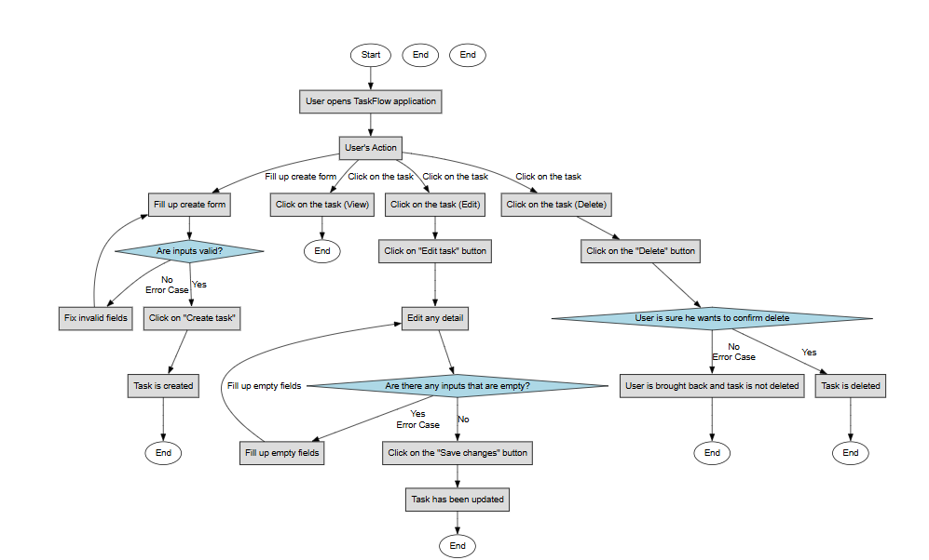

Individual Contribution
Elaborate on the feature that you proposed and have contributed to the project, with emphasis on the following:
- User's interaction with your function, including input, actions, and expected outputs.
- Comprehensive account of how your function interacts with the database.

Feature Name | Delete Task
User Interaction | Users can delete a task by clicking the Delete button associated with the task in the web application. Upon clicking, the user will be prompted with a confirmation message to ensure that they intend to remove the task. The feature is accessible directly from the task list interface, allowing users to manage their tasks easily.
Database Interaction | When the user confirms the deletion, the system sends a request to the backend to remove the corresponding task entry from the database. The database identifies the task by its unique task ID and performs a delete operation to permanently remove it from the tasks collection/table.
Inputs | The system requires the task ID as the primary input. This ID is passed to the backend when the user clicks the Delete button. The backend uses this identifier to locate and delete the correct task from the database.
Actions | if the user cancels the delete or click the button, it does not really work.
Expected Outputs | If successful:  Task will be deleted from the application's database and will no longer be visible to the user on the application.  If error:  Task will not be deleted and will stay on the web application.

Consider incorporating visual aids such as diagrams or screenshots to enhance clarity in your explanation. Suggested visual aids:

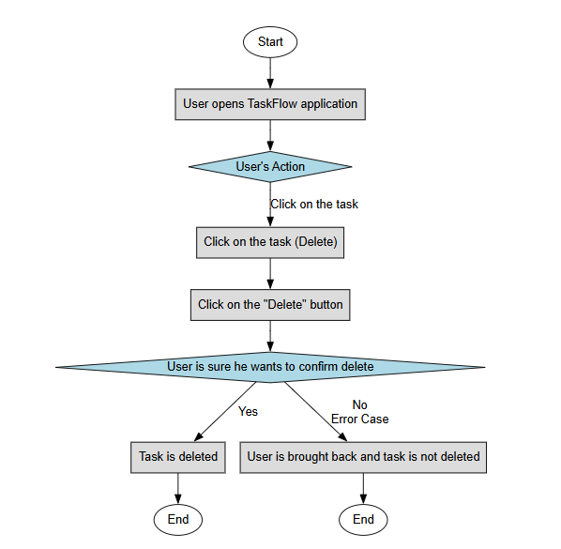

Version Control
Describe how Source Code Management was used in your team. Elaborate on:

repository structure: We structured our project with dedicated directories to maintain clarity and separation of concerns. Specifically, we created a utils folder to store backend-related functions, a public folder to contain our CSS and frontend JavaScript files, and a models folder for defining our data models.
With regard to naming conventions, we applied camelCase for all files within the utils folder to maintain consistency with typical JavaScript utility file practices. In contrast, we used PascalCase for the files in the models folder, reflecting their role as structured definitions or classes within the project
branching strategy: We adopted a structured branching strategy to ensure smooth and organised development. Each team member worked on their own feature branch, allowing us to develop individual functionalities independently without disrupting the main codebase.
We utilised the dev branch as a shared environment for integrating and testing these features collectively. This ensured that any issues could be identified and resolved before merging.
The main branch was reserved exclusively for finalised, stable code, representing the production-ready version of the project.
commit practices: We did not encounter any major merge conflicts during development, largely due to our effective use of a dev branch. The dev branch served as an intermediate testing environment where all features were integrated and verified before proceeding to the main branch. This approach allowed us to ensure that each implemented feature was functioning correctly and compatible with existing code, significantly reducing the likelihood of conflicts when performing the final merge into the main branch.
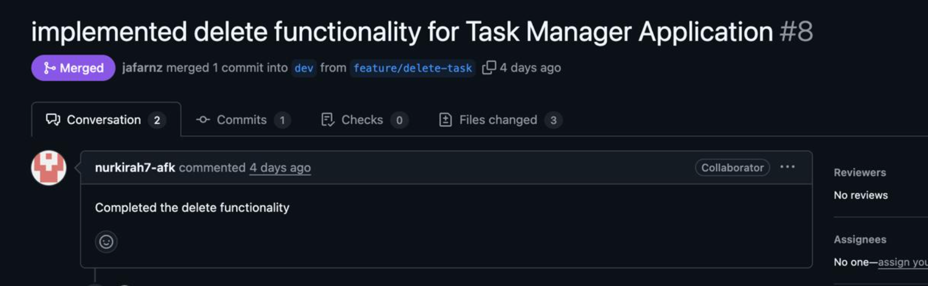

Additional Features
we are using:
.gitkeep
GitHub Issues
GitHub Labels

We incorporated the use of. gitkeep because we had predetermined the project’s directory structure from the beginning. Since GitHub does not track empty folders by default, the inclusion of a. gitkeep file allows these directories to be recognised and preserved during version control. This ensures that our intended folder hierarchy is clearly communicated to all team members and remains intact throughout the project lifecycle.

For GitHub Issues, we adopted this feature as a structured way to document, assign, and manage the various challenges and tasks encountered during development. By assigning issues to specific team members, we were able to distribute responsibilities more effectively, enhance accountability, and maintain a transparent record of ongoing work. This approach also improved our ability to track bugs, prioritise tasks, and ensure that nothing critical was overlooked.

Additionally, we made use of GitHub Labels to categorise and classify both issues and pull requests. Applying labels enabled us to group related tasks, highlight their urgency or type, and streamline our workflow. As a result, our project management process became more organised, and the team could more easily navigate and understand the status and nature of each item within the repository.

GitHub Labels
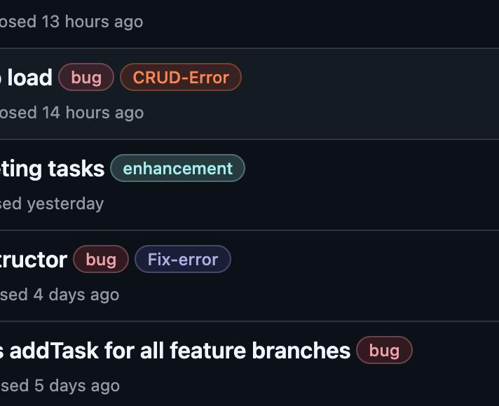

GitHub Issues
